**Machine Learning Based IMAGE SEGMENTATION**

**A PROJECT REPORT**

**Submitted by**

SATYAM SINGH

20BCS2162

**in partial fulfillment for the award of the degree of**

**BACHELOR OF ENGINEERING**

**IN**

**COMPUTER SCIENCE AND ENGINEERING**



**Chandigarh University**

**November -2022**



**BONAFIDE CERTIFICATE**

**Certified that this project report Machine Learning Based IMAGE SEGMENTATION is the bonafide work of SATYAM SINGH respectively who carried out the project under my/our supervision**

**SIGNATURE** **SIGNATURE**

|  |  |
| --- | --- |
|  | **NIVEDITA SHARMA** |
| **HEAD OF THE DEPARTMENT** | **SUPERVISOR** |
|  | **Assistant Professor** |
| **Computer Science and** |  |
| **Engineering Department** | **Computer Science and** |
|  | **Engineering Department** |

**Submitted for the project viva-voce examination held on ___________________**

**INTERNAL EXAMINER** **EXTERNAL EXAMINER**

**ii**

**TABLE OF CONTENTS**

|  |  |  |
| --- | --- | --- |
| **List of Figures** | | **v** |
| **Abstract** | | **vi** |
| **Graphical Abstract** | | **vii** |
| **Chapter 1 Introduction** | | **1** |
| **1.1** | **Client Identification/Need Identification** | **1** |
| **1.2** | **Identification of Problem** | **1** |
| **1.3** | **Identification of Tasks** | **2** |
| **1.4.1 Timeline** | | **2** |
| **1.4.2 Timeline Gantt Chart** | | **3** |
| **1.5** | **Organization of the Report** | **3** |
| **Chapter 2. Literature Review** | | **4** |
| **2.1** | **Timeline of the reported problem** | **4** |
| **2.2** | **Proposed Solutions and Bibliographic Analysis** | **4** |
| **2.3** | **Review Summary** | **5** |
| **2.4** | **Problem Definition** | **6** |
| **2.5** | **Goals/Objectives** | **6** |
| **Chapter 3. Design Flow/Process** | | **9** |
| **3.1** | **Evaluation and Selection of Features** | **9** |
| **3.2** | **Design constraints** | **9** |
| **3.3** | **Analysis and Feature finalization subject to constraints** | **10** |
| **3.4** | **Design Flow** | **10** |
| **3.5** | **Design Selection** | **11** |
| **3.6** | **Plan Implementation and Strategy** | **12** |
| **Chapter 4: Result Analysis and Validation** | | **13** |

**iii**

|  |  |  |
| --- | --- | --- |
| **4.1** | **Implementation of Design** | **13** |
| **4.2 Design Drawing** | | **13** |
| **4.3** | **Result** | **14** |
| **Chapter 5: Conclusion and Future Scope** | | **16** |
| **5.1** | **Conclusion** | **16** |
| **5.2** | **Future Scope** | **16** |
| **References** | | **17** |

**iv**

**LIST OF FIGURES**

**ABSTRACT**

Digital image processing supports a strong research program in the areas of image enhancement and image-based pattern recognition. Among the various image processing techniques, image segmentation plays an essential role in the given image analysis step. Image segmentation is the basic steps to analyze images and extract various data from them. This work covers the fundamentals of methods used to segment an image. Segmentation has become a major goal in image analysis and computer vision. For image segmentation, edge detection, thresholding, region development and clustering segmentation techniques are performed for this study. The segmentation algorithm is based on two properties of similarity and discontinuity. This article focuses on various widely used methods for image segmentation.

**v**

**Recommendation**

**CHAPTER 1**

**INTRODUCTION**

**1.1.** **Client Identification/Need Identification:**

Digital image processing finds many recent applications in the fields of remote sensing, medicine, photography, film and video production, and security surveillance. New advanced technologies are appearing in the fields of image processing, especially in the field of image segmentation.

Image segmentation is a process of compressing the original or previous image. The effect of the segmentation process is its speed, good shape matching and better shape connection with its segmentation result. Segmentation refers to

the process of identifying and isolating surfaces and regions of a digital image relative to structural units. Segmentation can also depend on different features present in the image. It can be color or texture

Segmentation algorithms have been developed for image segmentation; they are based on two basic properties, discontinuity and similarity. In the case of discontinuity-based partitioning and subdivision, they are performed based on sudden changes in the intensity level or gray level of the image. In this approach, our interest mainly focuses primarily on identifying single points, lines, and edges. In similarity-based grouping, pixels are similar in a certain sense, it includes approaches such as thresholding, region development, region splitting and merging..

**1.2.** **Identification of Problem**

Image segmentation is a commonly used technique in digital image processing and analyzing of partition of an image into multiple parts or regions, often based on the characteristic’s of the pixel’s in the images.

**1**

Every image’s processing technique or algorithm takes an input , an image or a sequence of images and produces an output, which may be a modified image or a description of the input image contents. Image Processing extracts informations from images and integrates it for several applications.

There are several fields in which image processing applications are relevant to the industry like Medical’s imaging , industrial’s applications, remote sensings, space applications, and military’s applications are a few examples.

Use image segmentation to extract information presented in data form from images.  
• Group pixels into salient image areas. H. Areas corresponding to individual surfaces, objects, or natural parts of objects.  
• Future goal is to implement image segmentation for autonomous driving calls.

**1.3.** **Identification of Tasks**

TRAINING MODEL FOR IMAGE SEGMENTING

EFFICIENCY INCREASE OF MODEL.

VAST COMPATIABLE DATASET.

**1.4.1. Timeline**

Satyam and Hasan will complete project design for this project over the course of 8 days. Satyam and Hasan will then work for 14 days on the Model part while Amit and Vikas will work for 15 days on the Dataset. And at the conclusion of the integration phase, all team members will work, and following that, minor adjustments (if necessary) will be made, taking a total of 9 days to complete.

**2**

**1.5. Organization of the Report**

**Introduction:**

In the current section of the report, we discussed about the Identification of project and its need, then we discussed about the identification of the problem and various questions related to the problem

**Literature Survey:**

In this section of the report, will we discuss about the existing works in the field of image segmentation, their pros and cons and then about the Goals/Objective of Our Project.

**Preliminary design/Design Flow:**

In this Section of the report, we will be discussing about the Design flow, Design Selection and Implementation Strategy of the project.

**Result and Validation:**

In this last section of the report, we will be discussing about the outcomes of the project, implementation of the solution and different tools used in the making of this application.

**Conclusion** and Future Scope:

In this part of the report, we will discuss about the final outcome, conclusion and the advancements that can be done in future

**3**

**CHAPTER 2.**

**LITERATURE REVIEW**

**2.1.** **Timeline of the reported problem**

What's the first thing you see when you look at a selfie? Your face, right? Your face can be recognized because the brain can identify your face and separate it from the rest of the image (background). If you want a computer to recognize your face in a selfie, is it possible?  
There has been a lot of research done on image segmentation, including medical image analysis, computer vision for self-driving cars, face recognition and facial recognition, video It is used in many fields such as surveillance, satellite image analysis. The history of using computers to segment digital images can be traced back 57 years. In 1965, the Roberts operator (also known as the Roberts edge detector), an operator for detecting edges between different parts of an image, was introduced and used to split image components (Roberts, 1965 ). Since then, the field of image segmentation has developed rapidly and undergone major changes. You can't do all of the above before image segmentation. That is why image segmentation plays a huge role in all of our lives.

**2.2.** **Proposed solutions and Bibliometric Analysis**

## Image segmentation is a branch of digital image processing that focuses on dividing an image into different parts according to its features and characteristics. The main purpose of image segmentation is to simplify images for easier analysis. Image segmentation divides an image into different parts with similar attributes. The parts that divide the image are called image objects. This is the first step in image analysis. Without image segmentation, it's almost impossible to do a computer vision implementation. Image segmentation techniques allow you to isolate and group specific pixels from an image, assign them labels, and classify additional pixels based on those labels. You can draw lines, set boundaries, and separate specific objects (important components) in the image from the rest (unimportant components).

Research in image processing has been sparse in the last decade, but has increased dramatically from 2014 to 2019. These days, the journal IEEE Access is the most relevant source of information, with an average of 115 publications per year. The United States is the most productive and its publications are widely cited, but China is her second. Image segmentation, feature extraction, and medical image processing are hot topics in recent years. The National Natural Science Foundation of China allocates 8% of its total funding to image processing. Image processing is now becoming one of the most important fields, so while research productivity has increased and more work has been done in the last five years, the era of 2005-2013 It was the area with the least amount of work in this area.

**4**

**2.3.** **Review Summary**

Image segmentation is a commonly used technique in digital image processing and used to analyze the partition of an image into multiple’s parts or regions, often based on the characteristics of the pixels in the image. Image segmentation involves separating foreground from background, or clustering region’s of pixels based on similarities in color or shape. For examples , a common application’s of image segmentation in medical imaging is to detect’s and label’s pixels in an image or voxel’s of a 3D’s volume that represents a tumor in a patient’s brain or other organs.

**5**

**2.4.** **Problem Definition**

What's the first thing you see when you look at a selfie? Your face, right? Your face can be recognized because the brain can identify your face and separate it from the rest of the image (background). If you want a computer to recognize your face in a selfie, is it possible? Yes, with the help of image segmentation.

**2.5.** **Goals/Objectives**

**•** Use image segmentation to extract information presented in data form from images.  
• Group pixels into salient image areas. H. Areas corresponding to individual surfaces, objects, or natural parts of objects.  
• Future goal is to implement image segmentation for autonomous driving calls.

**6**

**DESIGN FLOW / PROCESS**

**Image Segmentation**

Image segmentation is a method of dividing a digital image into different subsets called image segments, which helps reduce the complexity of the image to facilitate further processing and analysis of the image. Simply put, segmentation is the process of assigning labels to pixels. All image elements or pixels belonging to the same category are assigned a common label. Example: Consider a problem where you need to provide an image as input for object detection. Instead of processing the entire image, we can input the regions selected by the segmentation algorithm into the detector. This prevents the detector from processing the entire image, reducing inference time.

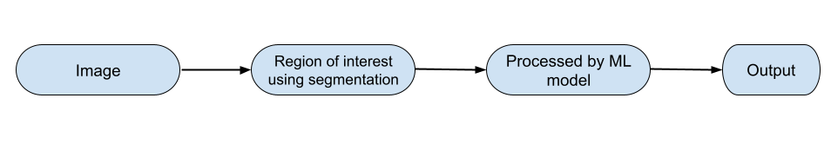

An image is a collection or set of different pixels. Use image segmentation to group pixels with similar attributes. Take a look at the image below (it gives you a working idea of image segmentation).

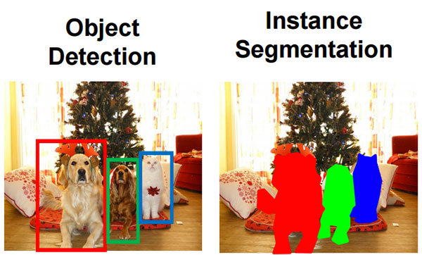

**LIBRARIES and MODULE WHICH IS USED FOR IMAGE SEGMENTATION**

**OpenCV** is a great tool for performing image processing and computer vision tasks. This is an open-source library that can be used to perform tasks such as face recognition, object tracking, and landmark detection. It supports multiple languages including Python, Java C++.

**scikit-image** is an image processing library that implements algorithms and utilities for use in research, educational, and industrial applications.

**PixelLib** is a library built to perform image and video segmentation with just a few lines of code. This is a flexible library created for easy integration of image and video segmentation into software solutions.

**TensorFlow** is an open source software library for powerful numerical computation. Its flexible architecture makes it easy to deploy computation across a variety of platforms (CPU, GPU, TPU), from desktops to server clusters, mobile devices, and edge devices.

**Steps** : Input Image

1. Pre processing
2. Image Segmentation
3. Feature Extraction
4. Classification
5. Normal
6. Abnormal

we simply separate the image segmentation techniques into three different classes

(1) feature-space based method,

(2) image-domain based method, and

(3) edge-based method.

Feature space-based methods consist of two steps: feature extraction and clustering. Feature extraction is the process of finding some features of each pixel or the area around each pixel. B. Pixel value, pixel color component, windowed mean pixel value, windowed variance, Rho's filter function, Tamura function, and Gabor wavelet function. etc.. After getting some symbolic properties around each pixel, I run a clustering process to split the image into some "meaningful" parts based on these properties. This is exactly what I tried in his DIP Homework 4 using his Law function in combination with the K-Means clustering algorithm. There are also many kinds of clustering algorithms such as Gaussian Mixture Models, Mean Shift, "Normalized Cut" in our project.

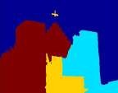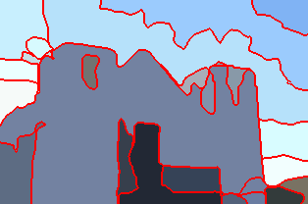

1. (b) (c)

Image domain based methods go through the image and find the boundaries between segments by some rules. The main consideration in dividing two pixels into different segments is the difference in pixel values, so this kind of method doesn't work well with textures. Split and Merge, Region Growing, and Watershed are the most common methods in this class. The third class is edge-based image segmentation methods consisting of edge detection and edge linking.  
  
There are many kinds of methods, but some common problems still cannot be solved. For class (1) it is still difficult to determine the exact boundaries between segments. Features get properties around each pixel, but not exactly. Class (2) uses only pixel value information and can lead to excessive partitioning of texture regions. Finally, due to the edge detection process, class  
(2) always suffers from oversegmentation problem. In our project, we use "Normalized Cut Framework" for image segmentation. It finds the best cut path from a global view (view of the entire image) rather than from a local threshold and is expected to yield better segmentation results than other methods. Section 2 introduces the basic ideas of the normalized truncation framework and its mathematical derivation.  
and Section 3 describe the functions used to measure similarity. Section 4 runs the image segmentation method on different types of images and presents the results. Finally, Section 5 provides discussion and conclusions about the project and lists some future work that could be continued for advanced research purposes.

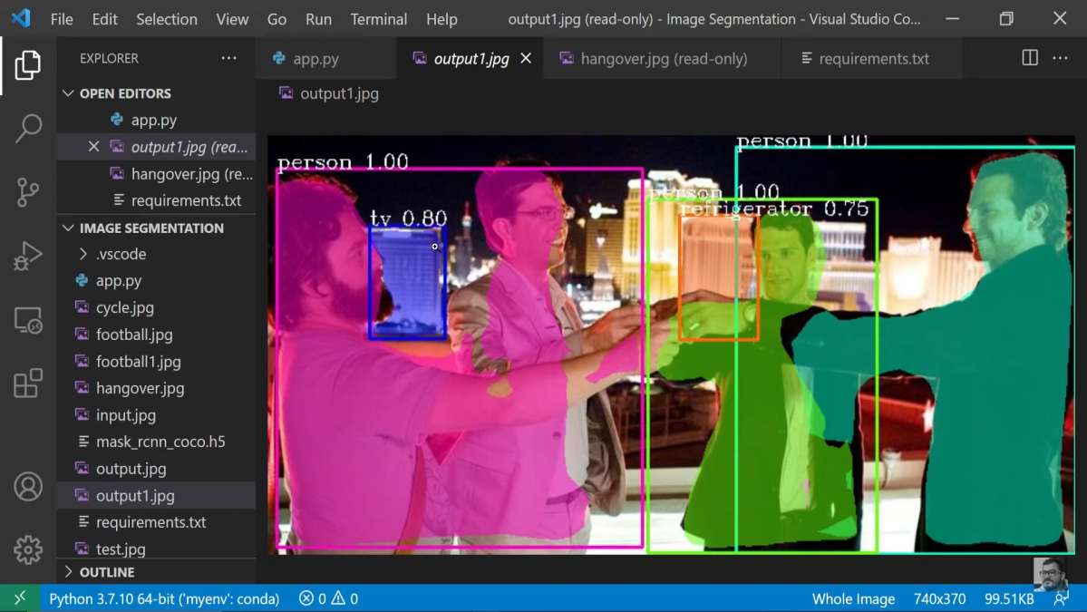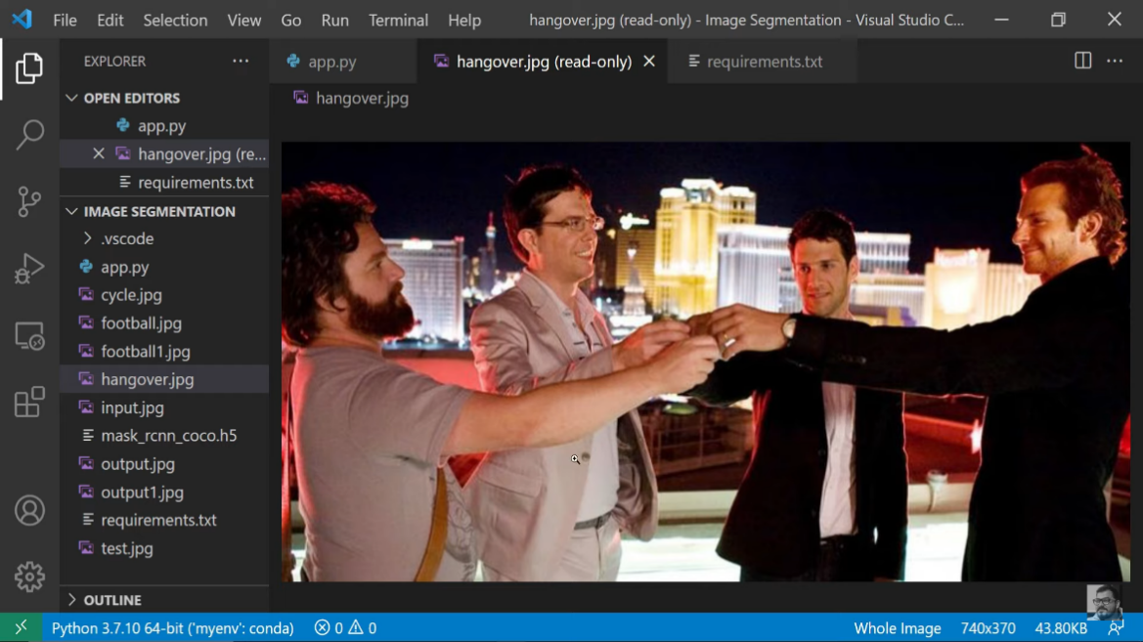

During image preprocessing, the images in the dataset are first converted to HSV images in order to detect exudates. Color space conversion aims to convert an image expressed in one color space to another color space and to make the converted image as close as possible to the original image. Converts the red, blue and green channels of the given image to hue, saturation and value.  
When converting RGB to HSV, it is useful to extract the yellow exudate from the RGB image. Then, after edge zero-padding, median filtering, and adaptive histogram equalization  
  
  
image preprocessing, we performed smoothing, masking, and bitwise AND to segment exudates. Smoothing is used to remove high spatial frequency noise from an image. Image blurring is achieved by convolving the image with a lowpass filter core. Masking is an image processing technique that defines small "picture pieces" and uses them to modify a larger image. Here, we mask the yellow ([60,255,255]) exudates and papillae in the smoothed image with blue ([0,0,0255]). The bitwise AND operation is used in image manipulation to extract important parts within an image.

**K-means clustering**

It is a famous tool to handle unsupervised classification problem. We show an example of k=3 groups in figure 3.11. The green points on the left graph mean we have a lot of data points in the space domain. After K-means we can separate these data points into three groups.

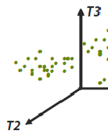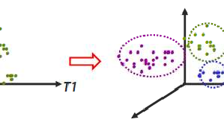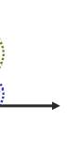

Figure 3.11: The left-hand side is the original data points in the 3-dimensional space, and the right-hand side is the k-means clustering result (3 groups).

**Gray level image**

For gray level images, we can simply use pixel value or the averaged pixel value in a window as the feature of each pixel.

**Color image**

For color images, we have many methods to identify the pixel including RGB (red, green, blue), HSV (hue, saturation, value) and HSL (hue, saturation, lightness) …etc. In our approach, we compute the mean square difference of the RGB values as the similarity between two pixels. Figure 3.1 and 3.2 show the color component basis and their responses on a natural image.

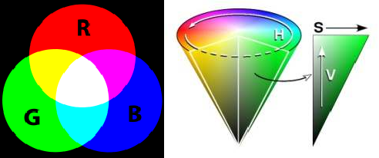

* + - 1. (b)

Figure 3.1: (a) is the color representation based on RGB color space, and (b) is based on HSV color space.

**Texton**

During image preprocessing, the images in the dataset are first converted to HSV images in order to detect exudates. Color space conversion aims to convert an image expressed in one color space to another color space and to make the converted image as close as possible to the original image. Converts the red, blue and green channels of the given image to hue, saturation and value.  
When converting RGB to HSV, it is useful to extract the yellow exudate from the RGB image. Then, after edge zero-padding, median filtering, and adaptive histogram equalization  
  
  
image preprocessing, we performed smoothing, masking, and bitwise AND to segment exudates. Smoothing is used to remove high spatial frequency noise from an image. Image blurring is achieved by convolving the image with a lowpass filter core. Masking is an image processing technique that defines small "picture pieces" and uses them to modify a larger image. Here, we mask the yellow ([60,255,255]) exudates and papillae in the smoothed image with blue ([0,0,0255]). The bitwise AND operation is used in image manipulation to extract

**12**

**CHAPTER 4.**

**RESULTS ANALYSIS AND VALIDATION**

# Introduction & Background

Humans perceive images as a whole. For us, deducing the information behind the image is a natural and intuitive task. On the other hand, for a computer, the image is a matrix consisting of numbers. Image segmentation is a broad and active area of ​​research in areas such as computer vision, satellite imaging, and the medical field. Its purpose is to divide an image into regions that are meaningful for a particular task. Different methods and approaches are used; The choice of a particular method depends on the nature of the problem to be solved and its place in the broader image analysis strategy. Segmentation is an essential step before describing, identifying, or classifying an image or its components. In other words, the purpose of image segmentation is to group pixels based on some characteristic be it color, shape, size, etc.

In this report, we explore a multitude of segmentation techniques based on different properties, such as discontinuous magnitudes – useful for edge detection – and similarity of values. intensity. The figure below depicts a typical imaging system that integrates the execution component into its process.

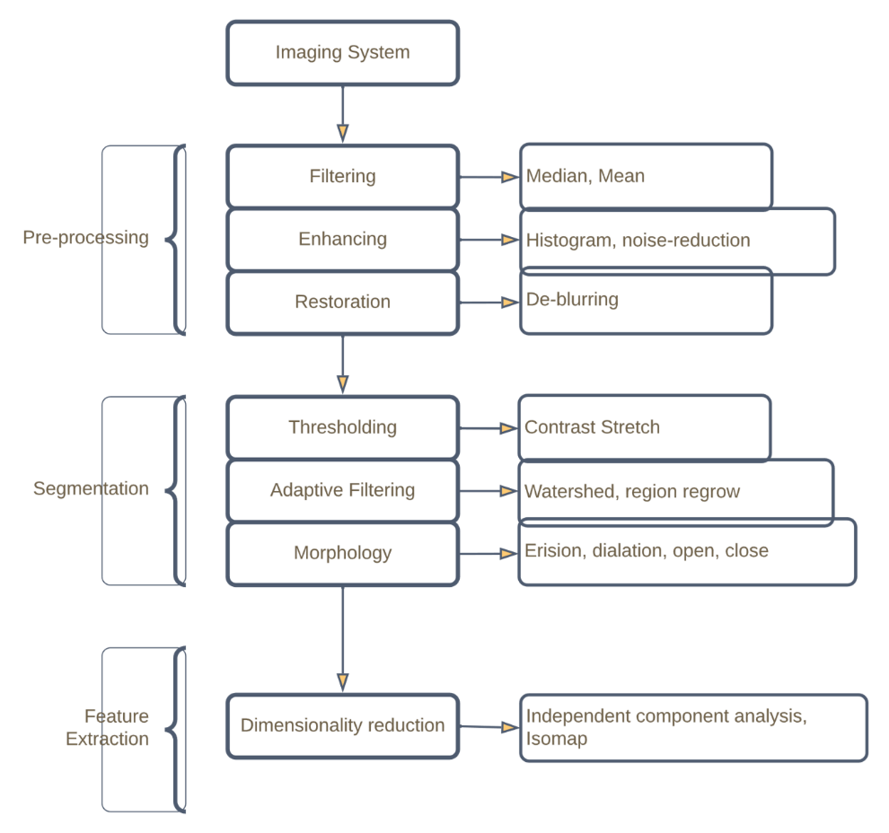

One may wonder why image segmentation is necessary. Image segmentation is an essential part of image analysis. It distinguishes between objects that we want to examine further and other objects or their background. For example, cancer has long been a deadly disease. Even in today's technologically advanced age, cancer can be fatal if not identified at an early stage. Detecting cancer cells as quickly as possible has the potential to save millions of lives. The shape of cancer cells plays an important role in determining the severity of the cancer. Image segmentation has a significant impact here. They help health care providers approach this in more detail and achieve more meaningful results; win-win for

# Thresholding

## Global Vs Adaptive Thresholding

Generating a global threshold is based on the assumption that the image has a bimodal histogram and therefore the object can be extracted from the background by a simple operation comparing the image values ​​with a threshold value. This means that a threshold is considered first. Any pixel value below the threshold gets a value of zero. Threshold is global in the sense that the same threshold is applied to all pixels of the image. This technique only works well if all images are taken in the same lighting conditions. This is usually not true.

Several conditions can combine to make it difficult to establish a global threshold. For example, poor image contrast can make it difficult to resolve the foreground from the background, resulting in overlapping peaks. Backgrounds of varying intensities can make it difficult, if not impossible, to choose a single threshold that fits the entire image. Poor spatial resolution, variable lighting, and subjects with varying levels of brightness can add to the difficulty. Therefore, for practical cases, adaptive thresholds are more common.

An ideal segmentation method for mutable background images is adaptive thresholding. In adaptive thresholding, instead of applying a single global threshold to all pixels in the image, the algorithm automatically changes the threshold across the image. In a locally adaptive threshold, each pixel is considered to have a × neighborhood around it, from which a threshold value is calculated (from the mean or median of these values) and the pixel is set to black or white, whichever is lower or higher than this local threshold.

Regardless of global or local adaptation thresholds, there are several algorithms for performing such thresholding.

## Otsu’s Thresholding Algorithm

In its simplest form, the Otsu algorithm returns a single intensity threshold that separates pixels into two layers, foreground and background. This threshold is determined by minimizing the intensity variance within the class, or equivalently by maximizing the variance between classes.

Otsu's algorithm is given as follows:

• Calculate the histogram and probability of each intensity level

• Set wi(0) and 𝑢i(0) initially using the available gray levels

• Cycle through all possible thresholds 𝑡 = 1, , magnitude maxima.

• Updating wi and 𝑢i

• Calculating 𝜎2(t)

• The desired threshold is at most 𝜎2(t)

Otsu's method shows relatively good performance if one can assume that the histogram has two-mode distribution and it has deep valley and steep distribution between two peaks. However, if the object area is small compared to the background area, graphs

,

no longer show two-dimensionality. In addition, if the subject variance and background intensity are larger than the mean difference, or if the image is severely damaged by additive noise, the sharp grayscale histogram valley will be degraded.

## Yen’s Thresholding Algorithm

TThe yen criterion is based on the consideration of two factors. The first is the difference between the threshold image and the original image, and the second is the number of bits required to represent the threshold image. Based on a single maximum correlation criterion for the two-level threshold, the bias is determined and then a cost function taking into account two factors is proposed for the multi-level threshold. By minimizing the cost function, the number of classifications to which the gray levels should be classified and threshold values ​​can be determined automatically. Furthermore, the cost function is shown to have a unique minimum under very mild conditions. Computational analyzes indicate that the number of operations required in the implementation of Yen's algorithm is much lower than the maximum entropy criterion.

## Simple Global Thresholding

### Case #1: 10_27a.tif



Figure 2.1 10_27a.tif

The image in 10_27a.tif was pretty straightforward and did not require any additional pre-processing or post-processing steps due to its evenly illuminated foreground and background.

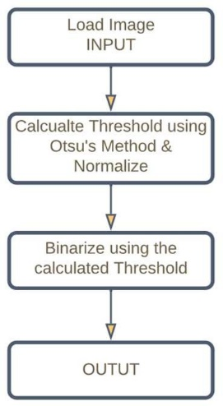Otsu’s segmentation algorithm, on a global scale, was used to obtain and acquire the segmented binarized image. The MATLAB implementation code is provided in *Appendix A*



Figure 2.2 Case # 1 | Algorithm Figure 2.3 Case #1 | 10_27a.tif thresholded

# Morphology

Morphological image processing is a set of non-linear operations related to the shape or morphology of objects in an image. Morphological operations are based only on the relative order of the pixel values, not on their numerical values, and are therefore particularly suitable for binary image processing. Morphological operations can also be applied to grayscale images such that their light transmission function is not known and, therefore, their absolute pixel values ​​are not or are of interest. heart.

Morphological techniques probe an image with a small shape or pattern called a structural element. The structuring element is positioned in all possible positions of the image and it is compared with the corresponding neighboring pixels. Some operations check if an element "fits" a neighborhood, while others check if it "touches" or cuts a neighborhood

A morphological operation on The binary image produces a new binary image where the pixel has a non-zero value only if the test is successful at this position in the input image.

• The structuring elements are a small binary’s image, i.e. a small matrix of pixels, each with a value of zero or one:

• The size of the matrix determines the size of the structuring element bamboo.

• The pattern of one and zero determines the shape of the structuring element.

• The origin of a structuring element is generally one of its pixels, although in general the origin can be outside the structuring element.

In other words, morphology is a large set of image processing operations that process images based on shape. Morphological operations apply a structuring element to an input image, producing an output image of the same size. In a morphometric operation, the value of each pixel in the output image is based on a comparison of the corresponding pixel in the input image with its neighbors.

The most basic morphological activities are expansion and erosion

Dilation adds pixels to the boundaries of objects in an image, while erosion removes pixels on the boundaries of objects. The number of pixels added or removed from objects in the image depends on the size and shape of the structuring element used to process the image. In morphological dilation and erosion operations, the state of a given pixel in the output image is determined by applying a rule to the corresponding pixel and its neighborhoods in the input image. The rule used for pixel processing determines whether the operation is dilation or erosion.

Dilation and erosion are often used in combination to perform image processing operations. For example, the definition of morphological openness of an image is erosion followed by dilation, using the same structuring element for both operations. We can combine dilation and erosion to remove small objects from the image and smooth the outlines of large objects. The close operation expands an image and then erodes the expanded image, using the same structuring element for both operations.

Morph close is useful for filling in small holes in an image while preserving the shape and size of the objects in the image. The morphological aperture is useful for removing small objects from the image while preserving the shape and size of the larger objects in the image.

A lot of images require morphological’s operations either before or after the primary segmentation process. The cases below show images that require such processing.

### Case #2: 10_27d.tif

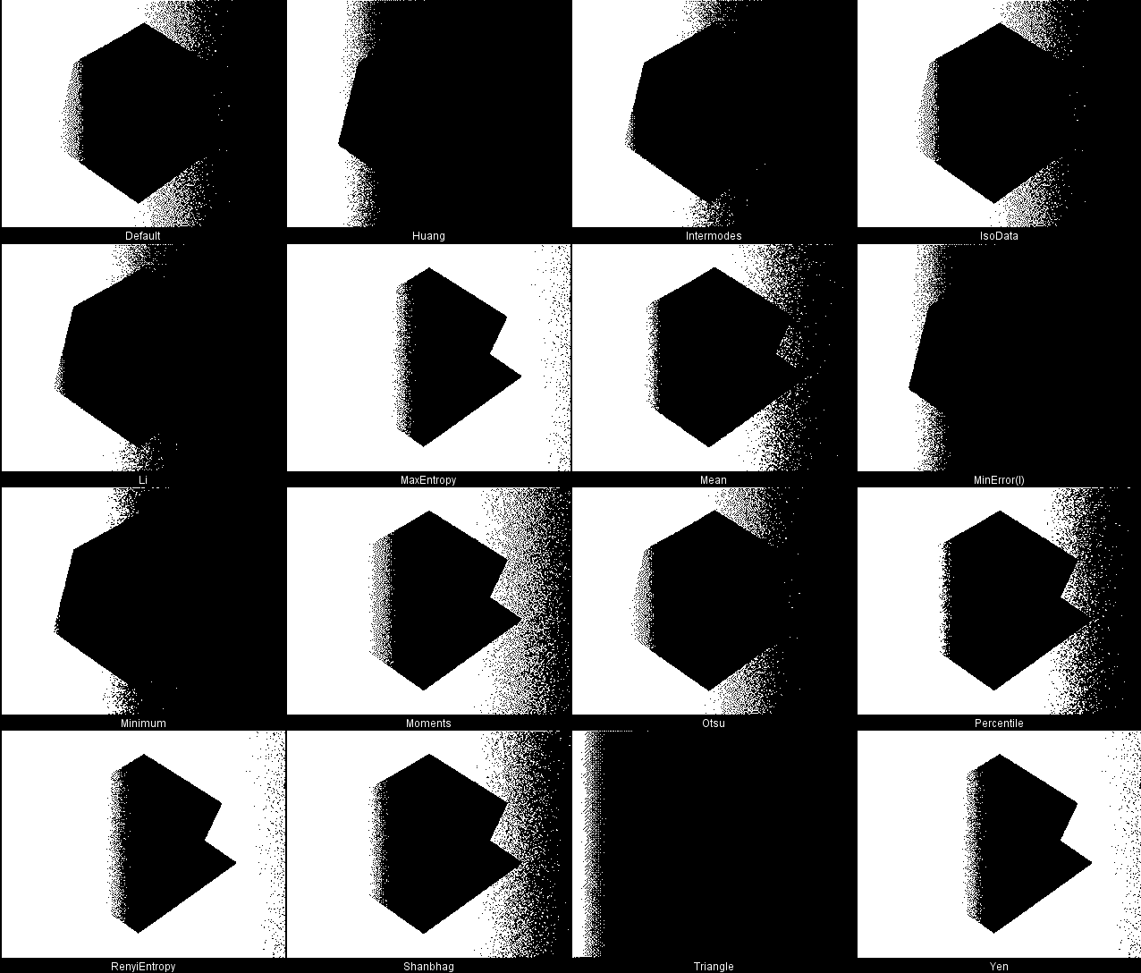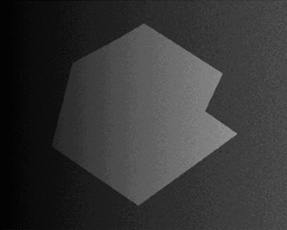

The Image 10_27d.tif has an uneven foreground and background. Applying various local and global thresholding algorithm did not yield any successful method as shown in the pictures below.

Figure 3.1 10_27d.tif

Figure 3.2 10_27d.tif thresholded globally using 16 different algorithms

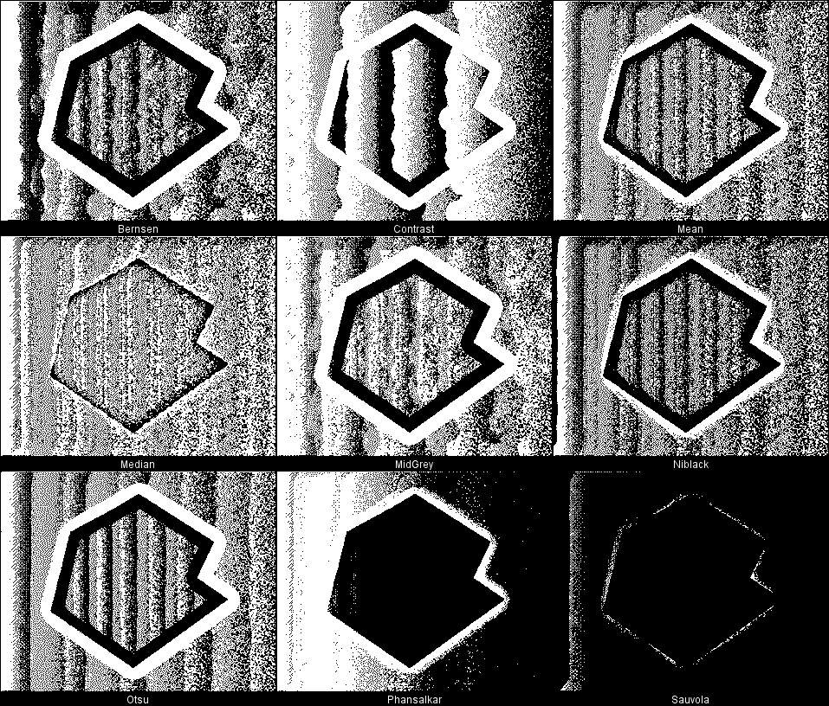

Figure 3.3 10_27d.tif thresholded adaptively using 9 different algorithms

### Case #2: 10_27d.tif Method 1

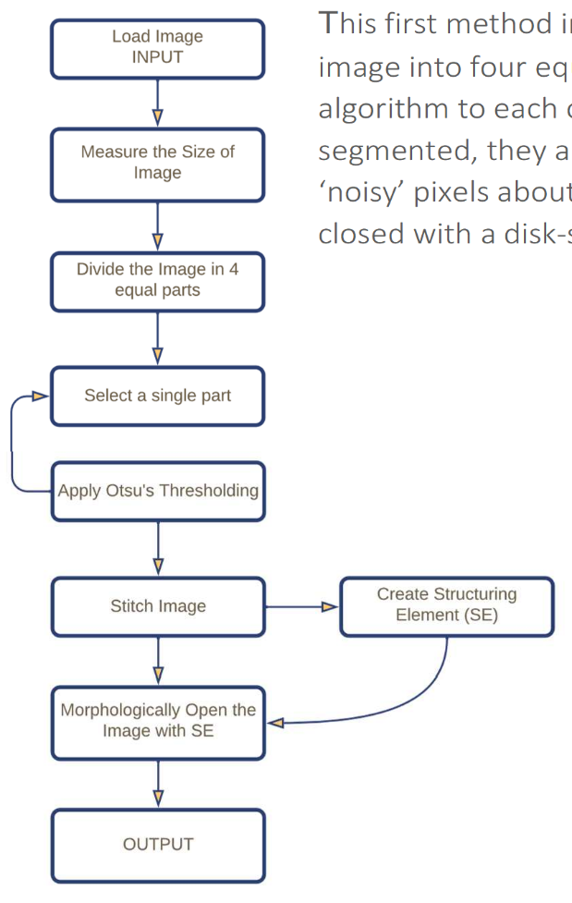corporated loading the image and then dividing the ual parts and the applying Otsu’s thresholding

This first method in

image into four eq algorithm to each segmented, they a ‘noisy’ pixels abou closed with a disk-

one of them. Once the individual parts were

re synthesized back together. Finally, to remove the t the vertical axis, the image was morphologically shaped structural element.

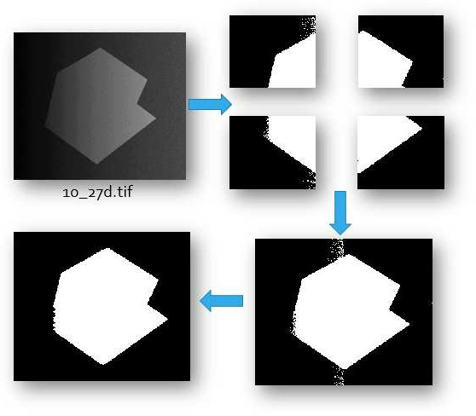

Figure 3.4 Case # 2 | Algorithm Figure 3.5 Case #2 Method 1| Segmentation Process

The MATLAB code for this algorithm’s is given in Appendix B1. It is evident that the foreground suffered from degradation on its left most extremities. This prompted for a second method involving preprocessing using background generation and subtraction which is discussed in the next chapter.

### Case # 3: Group of Disjoint Coins

In this case, a thresholding technique was devised to isolate a group of disjoint coins from an even background. A simple global thresholding using Otsu’s algorithm yielded much of the desired results. Morphologically closing the image with a structuring element of radius 2 pixels sealed up most of the holes in the image. MATLAB code is given in Appendix B2

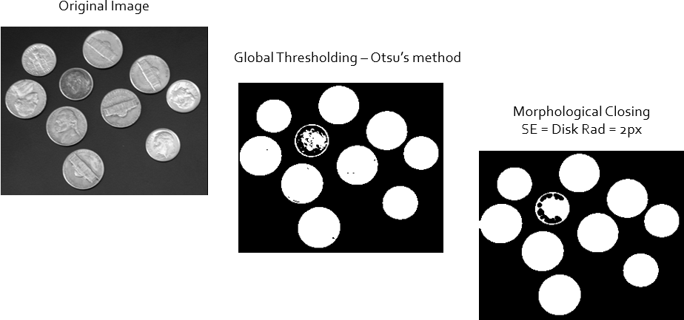

Figure 3.6 Case # 3 | Segmentation of an image of group of disjoint coins

### Case #4: Group of Coins 1

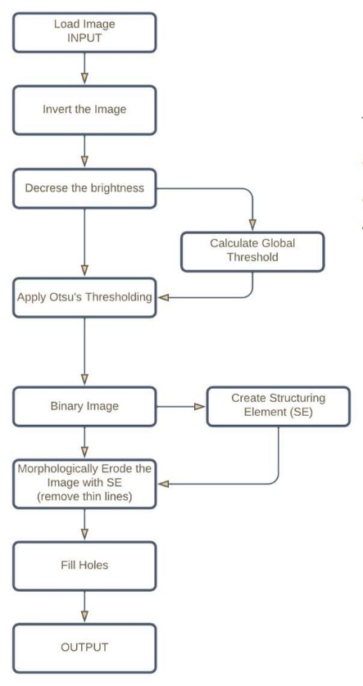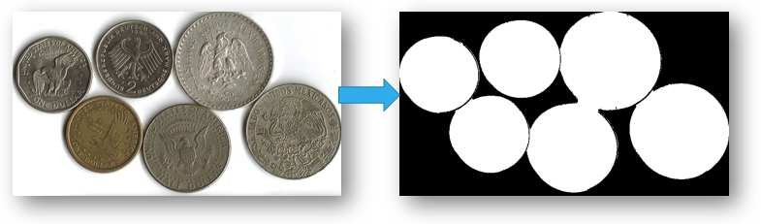

In this case, the chosen algorithm had to enhance the image

before applying the thresholding process. Nevertheless, this technique was not successful in identifying the coin boundaries and there were some bleed-over between coins. A better algorithm to segment such group of touching coins, known as the watershed algorithm, is discussed in the subsequent chapters. The MATLAB code is given in Appendix B3

Figure 3.8 Case #4 | Segmentation of an image of group of coins

Figure 3.7 Case #4 | Algorithm

**4.3** **RESULTS**

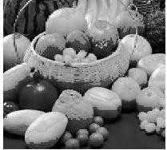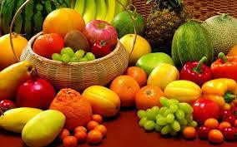

**Fig. 4.1: Screenshot**

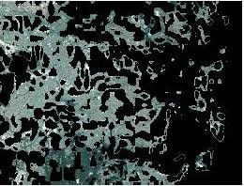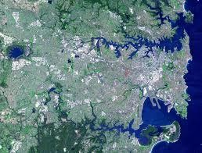

**Fig. 4.2: Screenshot**

**15**

**CHAPTER 5.**

**CONCLUSION AND FUTURE WORK**

**5.1.** **Conclusion**

Image segmentation has a promising future as a universal segmentation algorithm and has become the focus of contemporary research. As a result, image segmentation is influenced by many factors, such as image uniformity, spatial characteristics of image continuity, image texture, and content. In this work, different image segmentation techniques were discussed, an overview of several related image segmentation techniques was presented. The main image segmentation algorithms and image segmentation are discussed. In this study, an overview of different segmentation methods applied to digital image processing is briefly explained.

**5.2.** **Future work**

There are several fields in which image processing applications are relevant. Medical’s imaging , industrial’s applications, remote sensings, space applications, and military applications are a few examples.

**16**

**REFERENCES**

**. [1] Rajesh Dass, Priyanka, Swapna Devi, “Image Segmentation Techniques”, IJECT Vol.3, Issue 1, Jan-March 2012.**

1. **Gurjeet kaur Seerha, Rajneet kaur, “Review on Recent Image Segmentation Techniques”, International Journal on Computer Science and Engineering (IJCSE), Vol. 5 No. 02 Feb 2013.**
2. **Salem Saleh Al-amri, N.V Kalyankar, Khamitkar S.D, “Image Segmentation by using threshold Techniques”, Journal of computing, Volume 2, issue 5, may 2010.**
3. **R.Yogamangalam, B.Karthikeyan, “Segmentation Techniques Comparison in Image Processing”, International Journal of Engineering and Technology (IJET), Oct 2013.**
4. **A.M. Khan, Ravi.S, “Image Segmentation Methods: A Comparative Study”, International Journal of Soft Computing and Engineering (IJSCE) ISSN: 2231-2307, Volume-3, Issue-4, September 2013.**
5. **H.P. Narkhede, “Review of Image Segmentation Techniques”, International Journal of Science and Modern Engineering (IJISME), ISSN: 2319-6386, Volume-1, Issue-8, and July 2013.**
6. **Waseem Khan, “Image Segmentation Techniques: A Survey”, Journal of Image and Graphics, Vol. 1, No. 4, December 2013.**
7. **Sonam Saluja, Aradhana Kumari Singh, Sonu Agrawal, ” Study of Edge-Detection Method’s”, International Journal’s of Advanced Research in Computer and Communication Engineering Vol. 2, Issue 1, January 2013.**
8. **Lijun Ding, Ardeshir Goshtasby, “On the Canny edge detector”, Pattern Recognition 34 (2001), 721-725.**
9. **T.Romen Singh , Sudipta Roy, O.Imocha Singh, Tejmani Sinam, Kh.Manglem Singh “A New Local Adaptive Thresholding Technique in Binarization”, IJCSI International Journal of Computer Science Issues, Vol. 8, Issue 6, No 2, November 2011.**
10. **Matei Mancas, Bernard Gosselin, Benoît Macq,” Segmentation Using a Region Growing Thresholding”.**
11. **Ms. Chinki Chandhok, Mrs.Soni Chaturvedi, Dr A.A Khurshid,” An Approach to Image Segmentation using K-means Clustering Algorithm”, International Journal of Information Technology (IJIT), Volume – 1, Issue – 1, August 2012 ISSN 2279 – 008X.**
12. [**http://www.mathworks.com/**](http://www.mathworks.com/)
13. **X.R.C.Gonzalez, 2006, Digital Image Processing, Prentice Hall of India, Second Edition**

**17**